**Table of content:**

* + - * + Description
* About the Digital camera
* SWOT Analysis
  + - * + Requirements
        + Block Diagram
        + Design

**About the Digital Camera:**

To photos and capture video, a digital camera employs an electronic image sensor. A digital camera's optical system functions similarly to that of a film camera, with a standard lens and diaphragm employed to adjust electronic image sensor lighting.

Amateur and professional photographers both benefit from digital cameras' automated control features. The majority of functionality on advanced digital cameras may be controlled manually.

From personal digital assistants (PDAs) and mobile phones to the Hubble and Webb Space Telescopes, digital cameras are integrated into a wide range of digital devices. Digital photography is versatile and compatible with email, CD/DVD, TV and computer monitors, the Internet, and computer storage. Some digital cameras come with a built-in GPS receiver that can be used to create geotagged images.

The ability to examine video and images immediately is a fundamental benefit of digital photography. Cropping, recoloring, contrast/imperfection adjustment, and combining one or more photos are all done with image editing software.

**SWOT Analysis:**

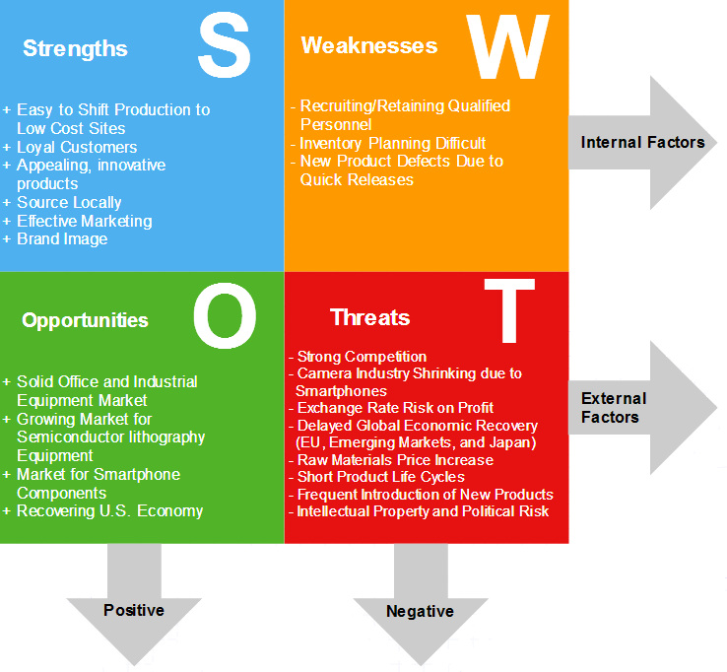

**Requirements**

**High Level Requirements:**

* Energy Reducing the amount of electricity or time used saves energy
* Battery life should be as long as possible.
* Must use an IC that fits in a camera of reasonable size.

**Low Level Requirements:**

* Battery life (power x time) Metrics that are restricted
* Values must fall below (or occasionally exceed) a specified threshold.
* Metrics for optimization Made as many improvements as possible to the product Metrics can be limited as well as optimised.

**Block Diagram**

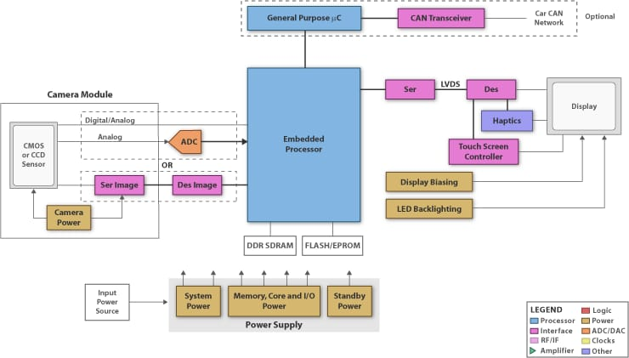

**Embedded processor:**

The microprocessor designed into a system to control electrical function and mechanical function.

**CMOS sensor:**

An active pixel sensor is a image sensor where each pixel sensor unit cell has a photo detector and one or more active transistor.

**CAN transceiver:**

The role of the transceiver is simply to drive and detect data to and from the bus. It converts the single-ended logic used by the controller to the differential signal transmitted over the bus.

**ADC**:

An analog-to-digital converter (ADC) is used to convert an analog signal such as voltage to a digital form so that it can be read and processed by a microcontroller.

**EPROM:**

A read-only memory whose contents can be erased by ultraviolet light or other means and reprogrammed using a pulsed voltage**.**

**Haptics:**

An experience of touch by applying forces, vibrations, or motions to the user.

**Design**

• Unit cost: The monetary cost of producing each system copy, excluding NRE costs.

• Cost of NRE (Non-Recurring Engineering): Once upon a time

the expense of developing the system in terms of money

• Dimensions: the system's physical dimensions.

• System performance: the system's execution time or throughput.

• Power: the system's total power consumption.

• Flexibility: the capacity to alter the system's functionality.